**LCD Code :**

#include <reg51.h> // Include register definition file for AT89C51

#define LCD P0 // Define LCD data port

sbit RS = P1^0; // Register Select pin

sbit RW = P1^1; // Read/Write pin

sbit E = P1^2; // Enable pin

void Delay(unsigned int ms);

void LCD_Command(unsigned char cmd);

void LCD_Char(unsigned char Data);

void LCD_Init(void);

void LCD_String(char *str);

void main() {

LCD_Init(); // Initialize LCD

LCD_String("ISQUAREIT"); // Display message

while (1); // Loop forever

}

void LCD_Init(void) {

Delay(20); // Wait for more than 15 ms after power on

LCD_Command(0x38); // 2 Lines, 5x7 Matrix

Delay(5); // Wait for a bit after this command

LCD_Command(0x0C); // Display ON, Cursor OFF

LCD_Command(0x06); // Increment cursor

LCD_Command(0x01); // Clear display

Delay(2); // Wait for clear command to complete

}

void LCD_Command(unsigned char cmd) {

RS = 0; // Command mode

RW = 0; // Write mode

LCD = cmd; // Send command

E = 1; // Enable high

Delay(1); // Delay for processing

E = 0; // Enable low

Delay(5); // Wait for command to be executed

}

void LCD_Char(unsigned char Data) {

RS = 1; // Data mode

RW = 0; // Write mode

LCD = Data; // Send data

E = 1; // Enable high

Delay(1); // Delay for processing

E = 0; // Enable low

Delay(5); // Wait for data to be written

}

void LCD_String(char *str) {

while (*str) {

LCD_Char(*str++); // Send each character

}

}

void Delay(unsigned int ms) {

unsigned int i, j;

for (i = 0; i < ms; i++) {

for (j = 0; j < 1275; j++); // Approx delay

}

}

**Interfacing Diagram:**

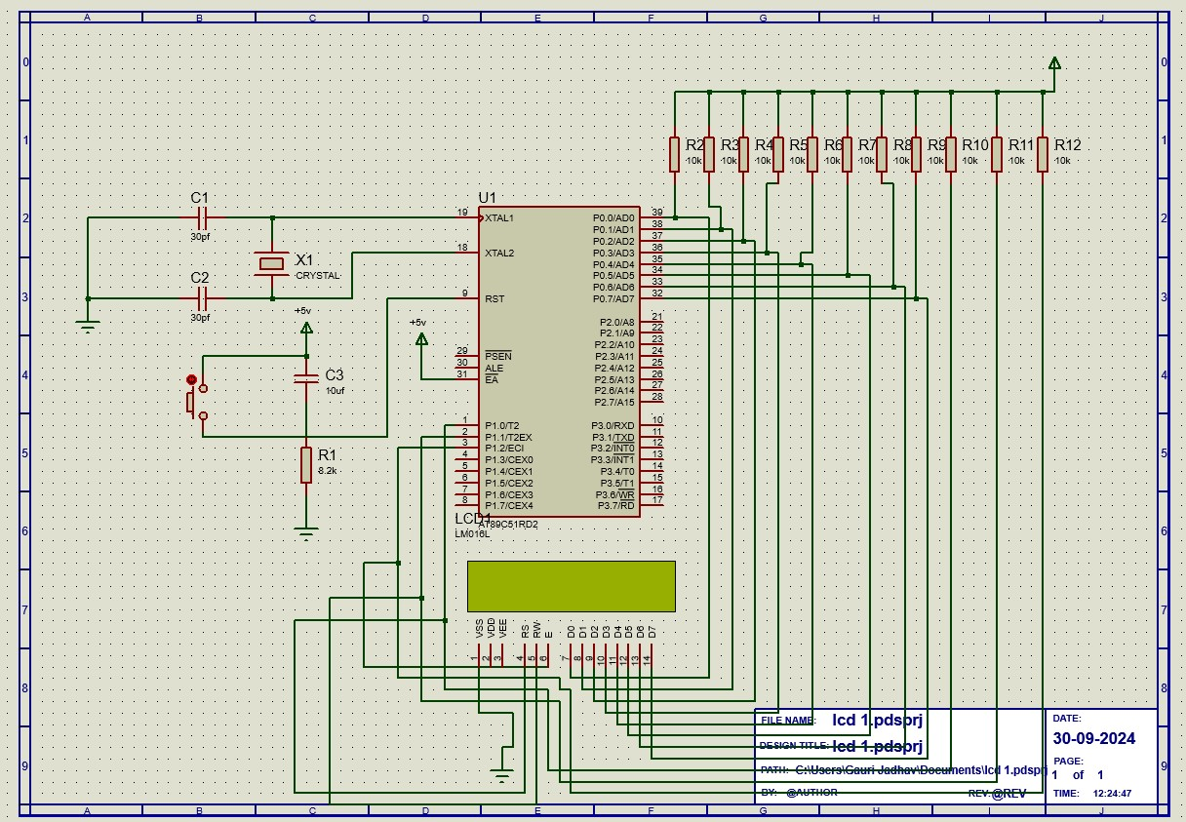

**Ouput:**

